**ARC 5917**

SRMS Integration

This project is for importing files from a custom Service Request Management System (SRMS). The settings menu is for setting the paths that the program will read from. There are two transactions, updating due dates and closing work order with WIP to FG. The due date file is expected to be a text file with the job number, suffix, and due date in it, in the format JOB-SUFFIX, MM/DD/YYYY. The Wip to FG file only needs JOB-SUFFIX. When WIP to FGing, the program will use a quantity of 1.

The processing script will run off the 38130 post online update hook. A log can be found in Global\Custom\5917\Log. Processed files will be moved to a Processed subdirectory in the directory they are read from.

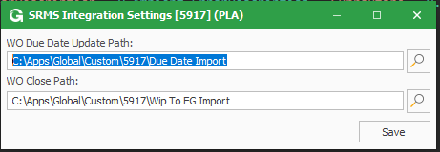

The menu for the path maintenance is at On Line System > Administration > SRMS Integration Settings [5917]. Here you maintain the paths that each transaction will be reading from.